第五章 染色体畸变答案
Chromosome Abberation
1．The deletion data allows you to narrow down the region in which the genes lie. All of these deletions remove portions of polytene chromosome region 65 (which turns out to be on chromosome 3, a Drosophila autosome). Deletion A shows pseudodominace for javelin and henna, so all or part of both genes must lie within the deleted region - between A2-3 and D2-3. Deletion B, pseudodominant for henna, indicates that henna lies between C2-3 and E4-F1. Combining the results for Deletions A and B, henna must be between C2-3 and D2-3. Because Deletion B is javelin+, javelin must be located between A2-3 and C2-3 (the part of Deletion A that is not removed in Deletion B). Deletions C and D tell you that the henna gene cannot lie to the right of bands D2-3 on the figure in the text, delimiting henna to the interval between C2-3 and D2-3.
Inversions do not remove genes, they just relocate them. Therefore, if the inversion is made in a wild type chromosome, the inverted homolog will have the wild type alleles for all of the genes. Inversion B gives the expected result, and does not help locate either of the two genes. Inversion A, however, has a mutant javelin phenotype, indicating that there is a mutant allele of javelin on the inverted homolog. Thus, the javelin gene was broken by the inversion, so javelin is located in band 65A6. (This is consistent with the region containing javelin determined from the deletions above.) Very few Drosophila genes extend beyond one band, so we can assume that A6 is the location of javelin. In summary, the javelin gene is in band 65A6 and the henna gene is between 65C2-3 and 65D2-3.

2．The data shows unexpectedly reduced recombination frequencies between certain pairs of genes in Bravo/X-ray and Bravo/Zorro heterozygotes. This reduction in recombination will be seen in both deletion heterozygotes and in inversion heterozygotes. You are told that the 3 strains have variant forms of the same chromosome, and that the number of bands in the polytene chromosomes is the same in all 3 strains. Thus, none of the strains is a deletion homozygote. The chromosomal rearrangements here must be inversions.
a. Recombination frequencies between genes in the Bravo/X-ray heterozygote are normal for a-b and b-c and g-h but are reduced for all other gene pairs. Thus, the inversion in the X-ray strain breaks between genes c-d and between genes f-g and inverts genes d, e, and f. The c-d and f-g intervals must still include some non-inverted DNA to allow recombination that produces viable gametes. Similarly, the genetic distance is reduced in the b-c and f-g intervals for Zorro, where the inversion end points are found and minimal in those intervals completely within the inversion. The order of the genes in X-ray is: a b c f e d g h. The order of the genes in Zorro is: a b f e d c g h.
b. The physical distance in the X-ray homozygotes between c and d is greater than that found in the original Bravo homozygotes. The inversion occurred in this portion of the chromosome, so c and d are now separated by many more genes (all the inverted DNA).
c. The physical distance between d and e in the X-ray homozygotes is the same as that found in the Bravo homozygotes because this interval is completely within the inverted segment. The relationship of d to e has not changed.

3．In this problem, the diploid cell contains a paracentric inversion on one homolog. The pairing of the homologous chromosomes during metaphase I of meiosis in the inversion heterozygote is shown below. Use this drawing to trace the consequences of crossovers in different regions.
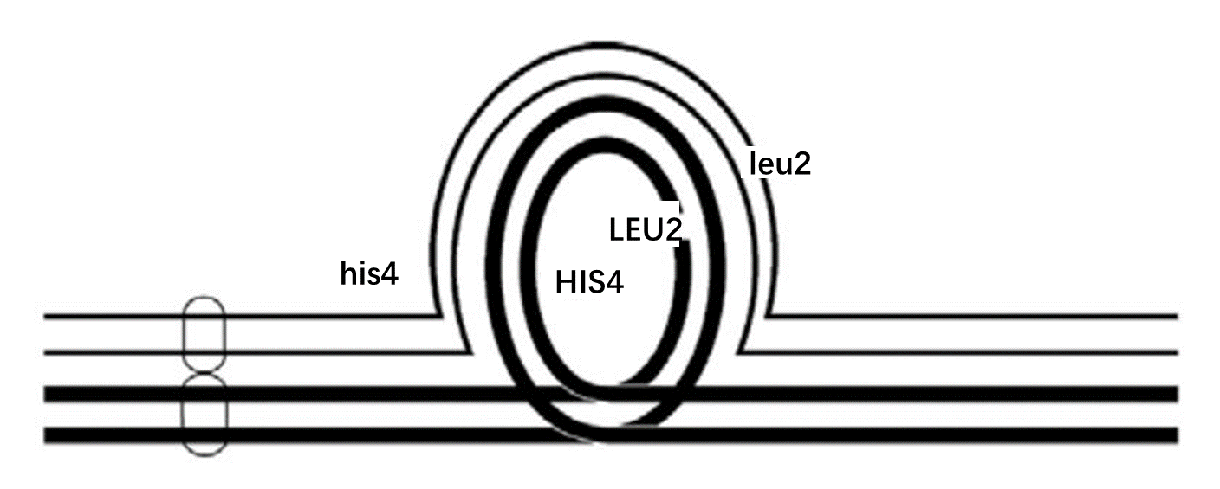
a. A single crossover within the inversion (between HIS4 and LEU2) leads to 2 parental spores (one of each type) and 2 recombinant spores. The recombinants result in imbalanced spores, containing both a duplication and a deletion for the regions outside the inversion loop. In this case, one of the recombinant spores will be duplicated for the region containing the centromere and deleted for the DNA on the other side of the inversion loop (dicentric). The reciprocal recombinant spore will be deleted for the region containing the centromere and duplicated for the region to the right of the inversion loop (acentric). Neither type of chromosome segregates properly so the spores that receive these chromosomes will definitely die. The acus will contain: 1 HIS4 LEU2 (prototrophic for histidine and leucine) : 1 his4 leu2 (auxotrophic for histidine and leucine) : 1 dicentric (lethal) : 1 acentric (lethal).
b. This is a 2 strand double crossover within the inversion loop. All four spores are viable: 2 HIS4 LEU2 (1 parental and 1 recombinant) : 2 his4 leu2 (1 parental and 1 recombinant).
c. A single crossover between the centromere and the inversion loop will give 2 parental spores and 2 balanced recombinant spores: 2 HIS4 LEU2 (1 parental and 1 recombinant) : 2 his4 leu2 (1 parental and 1 recombinant).
4．Any haploid spores with a deletion are dead (white). An octad has 8 spores.
a. 0 white spores. The inversion has no effect if recombination does not occur.
b. 4 white spores. Only two chromatids are involved in the crossover. The recombination gives 2 unbalanced gametes. The remaining two chromatids survive as haploid products and divide mitotically to form 4 viable spores in the ascus.
c. 0 white spores. If a crossover occurs outside the inversion loop all the products are viable.
d. 8 white spores. All of the resulting gametes would be genetically imbalanced and would die.
e. 0 white spores. Alternate segregation produces balanced gametes.
f. 0 white spores. The crossover in the translocated region would simply cause the reciprocal exchange of DNA between homologous portions of the chromosome. All spores live.
5．a. Diagram the cross. Because the two genes are on different autosomes, they should assort independently:
cn cn⁺ ; st st⁺ × cn cn ; st st
↓
1/4 cn st (white) : 1/4 cn st+ (cinnabar) : 1/4 cn+ st (scarlet) : 1/4 cn+ st+ (wild type)

b. The genes show pseudolinkage in this male. The cn st and cn+ st+ allele combinations seem to be linked. This result suggests that the unusual male has a translocation between chromosome 2 and 3 with the mutant cn and st alleles either on the translocated chromosomes or on the normal chromosomes. The figures below show two of the four possible genotypes for the unusual male fly. Both diagrams show the mutant alleles on the normal order chromosomes. Instead, the mutant alleles of the genes could both be on the translocated chromosomes. Although both the cn and st genes may actually be on the same chromosome after the translocation (right hand panel), this is not necessary. The pseudolinkage will be seen even if the 2 genes are still on separate chromosomes (left hand panel). Also remember that male Drosophila does not recombine.
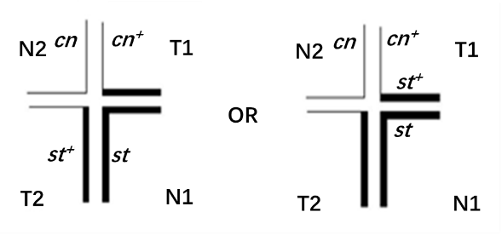
c. The wild-type F₁ females are translocation heterozygotes containing the cn⁺ and st⁺ alleles on the translocated chromosomes (she obtained the cn and st alleles from her non-translocated mother). The pairing in meiosis would be the same as shown for the male in part b, except that recombination can occur in the female. A crossover between cn and the translocation breakpoint or between st and the translocation breakpoint followed by alternate segregation produces gametes with the genotype cn st⁺ (cinnabar) cn⁺ st (scarlet). These classes allow you to calculate the map distance between the st and cn genes in the translocation. The rf = 10 mu.
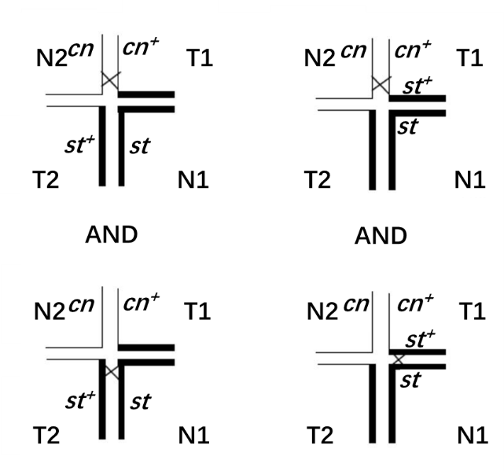
6． Individuals that are homozygous for a translocation are fertile. However, when insects that are translocation homozygotes mate with insects with normal chromosomes, the F₁ progeny will be translocation heterozygotes. The fertility of these F₁s should be reduced by about 50% and half of their progeny will also have reduced fertility. If the released insects are homozygous for several different translocations, then the fertility of the F₁ individuals should be reduced by a further 50% for each translocation for which they are heterozygous. For example, in an F₁ insect that was heterozygous for 3 different translocations (T1 - T3), only 1/8 of its gametes (1/2 balanced for T1 1/2 balanced for T2 1/2 balanced for T3 = 1/8 balanced gametes) would be balanced and give rise to progeny.
7．It is easiest to work this type of problem if you figure out the sizes of the genomic fragmentsand place these on the map. Remember that the probe extends from 2.6 kb to 14.5 kb.
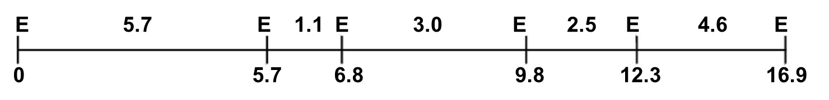
a. 5. The base change exactly at coordinate 6.8 will alter the restriction recognition site at that position and therefore the 1.1 and 3.0 kb fragments will disappear to be replaced by one new 4.1 kb fragment.
b. 3. A point mutation at position 6.9 has no effect on these restriction fragments since there is no EcoRI site at that position.
c. 2. This deletion removes 0.3 kb of DNA within the 2.5 kb fragment, resulting in the loss of the 2.5 kb fragment and the appearance of a new 2.2 kb fragment.
d. 6. This deletion removes 0.3 kb of DNA including a restriction site. The 1.1 and 3.0 kb restriction fragments would disappear and be replaced by one new 3.8 kb fragment.
e. 8. The insertion of a transposable element at coordinate 6.2 will change the size of the 1.1 kb fragment. The 1.1 kb fragment will disappear and be replaced by a new larger fragment. If the transposable element has a restriction site in it, the 1.1 kb fragment will be replaced by 2 new fragments, one a minimum of 0.5 kb and the second a minimum of 0.6 kb in size. Because the new fragments actually seen are 4.9 and 2.3 kb long, the results suggest that the transposable element is at least (4.9 + 2.3 – 1.1) = 6.1 kb long; it could be even larger if the transposable element has more than one site for this restriction enzyme.
f. 10. An inversion with breakpoints at 2.2 and 9.9 will alter the two fragments in which the breakpoints are located but will not affect the 1.1 and 3.0 kb fragments that occur in between. Thus the 5.7 kb and 2.5 kb fragments will disappear and be replaced by a 5.9 kb fragment and a 2.3 kb fragment. The total size of this region of the genome will not change.
g. 7. The reciprocal translocation will cause the 2.5 kb fragment to disappear. Two new fragments will be seen, each containing part of the 2.5 kb fragment. One of the new fragments will be a minimum of 0.3 kb and the other will be a minimum of 2.2 kb.
h. 1. A reciprocal translocation with a breakpoint at 2.4 will cause the 5.7 kb fragment to disappear. This will be replaced by 1 new fragment with a minimum size of 3.3 kb. The sequences between coordinates 0 and 2.4 will also be connected to DNA from the other chromosome; though this will make a new restriction fragment, it will not be visible in this Southern blot because the probe does not include any of this DNA.
i. 4. The duplication will increase the size of the 2.0 kb fragment by 3.0 kb, creating a new 5.0 kb fragment. The restriction map makes it clear that these duplicated sequences do not contain a site recognized by the restriction enzyme.
j. 9. The 2.5 kb fragment is maintained but the 4.6 increases to 6.6 kb. Because there is a restriction site within the region that is tandemly duplicated, a new fragment of 2.0 kb is now present.

